Cognitive Walkthrough for Learning Through Game Mechanics
David Farrell, David C Moffat
Glasgow Caledonian University, Glasgow, Scotland
david.farrell@gcu.ac.uk
d.c.moffat@gcu.ac.uk
Abstract. Whilst widely advocated, Games Based Learning (GBL) is still an unproven discipline. Results vary and there is no consensus for how best to teach a set of learning objectives using games. Designers may base their approach on reasonable pedagogical principles but the process of design is still driven largely by intuition and greater resembles craft than science. Humans are notoriously poor at unsupported methodical thinking and relying so much on intuition carries great risk in GBL design. Cognitive Walkthrough (CW) is a technique that improves our ability to predict how a user will understand an interaction. Whilst CW is long established in user-interface design, it should be considered a general purpose technique for crafting experiences where a designer must predict the general thinking process of a user. Extending CW to GBL can help designers expose and question their implicit assumptions and can be used during design to lower risk or during evaluation to understand results. Extensions of CW should map to the GBL pedagogical approach chosen to provide the most cognitive support. We present an extension of Cognitive Walkthrough for Learning Through Game Mechanics and apply it to the previously evaluated e-Bug Platform game to understand why one section achieved significant knowledge change and another did not. We found each section to assume several steps of logical understanding by users but those in the unsuccessful section were unreasonable assumptions. The new technique described in this paper explains hitherto puzzling results and identifies the strengths and weaknesses of game mechanics’ contributions to learning.
Keywords: Games Based Learning, Cognitive Walkthrough, Game Design, Constructive Alignment, Game Mechanics, Serious Games
1. Introduction
Whilst there is much enthusiasm for using games in education, most claims have not been confirmed in studies (Foster and Mishra 2009). Conclusions about learning in games differ (Mitchell & Savill-Smith 2004; Kirriemuir & McFarlane 2004) and many evaluations of Game Based Learning (GBL) are weak and unreliable (Wideman et al 2007). In order to improve GBL, it is necessary to build on sound pedagogical design principles (Freitas 2006), but game design is more of a craft than science and it is not clear how to do this. Some have attempted to integrate educational theories into game design for specific pedagogical approaches like Problem Based Learning (Kiili 2007), while others propose identifying reliable learning mechanic patterns that can then be easily integrated into games as required, without particular change to a game designer’s process (Plass et al 2011). For most GBL designers however, pedagogical principles act as guidelines rather than reliable processes and much is left to designer intuition. If a GBL game must help a player learn something new, the difference between the designer’s expertise and the players’ means that it is easy for a designer to make incorrect assumptions about what a player will and will not understand. Outside of extensive playtesting (expensive both in terms of time and cost), there are few techniques available to designers to bridge this “gulf of understanding” (Norman and Draper 1986), mitigate risk and increase the chances that the desired learning outcomes will be achieved.
The lack of reliable, practical techniques to support GBL pedagogy design is paired with a similar problem when evaluating a completed design, or a finished game. It is not obvious how we can systematically analyse GBL to determine how closely it adheres to a given pedagogical approach. Assuming that pedagogy driven design was implemented in good faith across a whole game, it is further not clear how one can understand why results vary from section to section.
An examination of the e-Bug platform game serves as an example of the evaluation problem. The design team attempted to make decisions on sound pedagogical principles based on work by Koster (2005), Squire (2004), and Shaffer (2006) that suggested successful ways that games teach. However, after development, the game was evaluated for knowledge change. Of the 21 Learning Outcomes assessed, 3 achieved statistically significant knowledge change (Farrell et al 2011). The evaluation speculated on potential reasons for this but could draw no clear conclusions or suggest what changes should have been made to improve the results
The Human Computer Interaction (HCI) technique Cognitive Walkthrough (CW) may be a suitable tool for addressing both of these concerns. This paper argues for wider adoption of CW in GBL and suggests that CW may be extended to any pedagogical approach to improve consistency both in designing GBL and in evaluating and understanding knowledge change results. As a proof of concept, we present one extension of CW for Learning Through Game Mechanics (CWLTGM) and use it to interpret the e-Bug Platform Game results. The CWLTGM offers plausible reasons for the differences and supports the promise of the benefit of extending and applying CW to GBL.
2. The e-Bug Platform Game
e-Bug was a European Commission, DG-SANCO funded project that aimed to improve young people’s understanding of microbes, hygiene and antibiotics, with the ultimate aim of reducing antibiotic misuse. As part of e-Bug, two games were designed that could be included in, or work independently of, curricula across 18 partner countries in Europe. One of those games was the e-Bug Platform Game, designed for primary school children aged 9-11. Because the game’s goal was to teach the player, it was important that it be based on good pedagogy.
2.1 Designing e-Bug to be Pedagogically Sound
It is not obvious how best to teach through games. Indeed, it is likely that there will never be a one-size-fits-all solution, but rather, different pedagogical approaches will be adopted depending on the type of learning required. Each approach is motivated by a particular belief about the likely effect of interaction with the game.
The game’s pedagogical approach was inspired by work by Koster (2005), Squire (2004), and Shaffer (2006) that explored how players construct knowledge by noticing how a game responds to their actions. These scholars highlight the role of game mechanics in constructivist learning. Game mechanics are “rule based systems / simulations that facilitate and encourage a user to explore and learn the properties of their possibility space through the use of feedback mechanisms” (Cook 2006). They are used to define the way the system behaves, and as a result, the things the player learns.
However, even though Squire found that players of Civilization learned about history by interacting with game mechanics, the game wasn’t teaching the same content as school curricula and so is ultimately inappropriate as a teaching tool.
Constructive Alignment (Biggs 1996) offers a way to take advantage of constructivist understandings of learning whilst being compatible with curricula. In a Constructively Aligned process, a teacher understands a learner’s existing knowledge, and the desired learning outcomes, and then attempts to deliberately align an experience to allow the learner to construct new knowledge as a result. Whilst unaware of Constructive Alignment at the time of designing e-Bug, the designer’s intuition was based on the same concept. In this case, by crafting game mechanics to create a game experience that would allow the player the opportunity to achieve the learning objectives.
For e-Bug, the scientist domain experts and teachers identified Learning Outcomes (LOs) and the designer attempted to convert each LO into a game mechanic that would highlight its meaning in a game context. For example, as Figure 1 shows, to teach that “We use good microbes to make things like bread and yogurt”, a game mechanic was introduced that allowed the player to push a Lactobacillus bacterium into a glass of milk, which would then turn into a glass of yogurt.
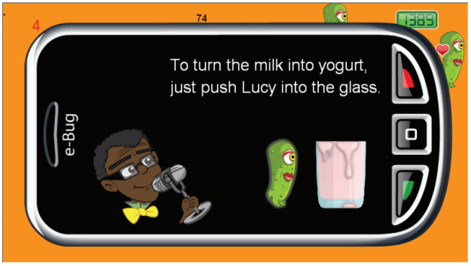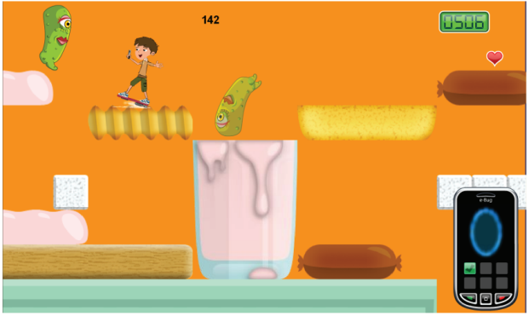
Figure 1: Constructivist game mechanics supporting learning about microbes & yogurt.
2.2 Evaluating e-Bug
To evaluate the effectiveness of e-Bug, in-game pre-post tests were inserted on either side of each section of the game. Data was collected during school visits and via the e-Bug website which allowed access to the game.
The evaluation (Farrell et al 2011) used 1736 players (62 from schools and 1674 online). McNemar’s test was used to assess paired data, applied to individuals with a change in response from ‘wrong’ or ‘don’t know’ to correct, or vice versa. Of the 21 LOs targeted by the game, only three achieved statistically significant knowledge change: we use good microbes to make things like bread and yogurt (P<0.001, x²=14.46); if you cannot see a microbe it is not there (P=0.02, x²=5.60); soap can be used to wash away bad bugs (P=0.02, x²=5.28).
The fundamental causes of variance between successful and unsuccessful parts of the game are not obvious. The same domain experts, teachers, and development team worked on all sections of the game and used the same constructivist, game mechanic oriented, constructively aligned process to create all sections. It is likely that some kind of “designer error” is responsible for the difference in effectiveness, but lacking GBL specific analysis tools, it is necessary to look to more established fields, such as HCI, for techniques that can be adapted to suit the domain-specific needs of Serious Games.
3. Cognitive walkthrough for GBL
Cognitive Walkthrough (CW) is an evaluation technique that helps an expert (who may also be a designer) to think like their target user through a structured process. This process encourages first thinking about the user and defining the system, and then takes a step-by-step approach to examining the design while the evaluator tries to imagine the user’s response. Because design is typically iterative, perhaps with several prototypes, CW can be applied during early design phases where problems in a design can be discovered prior to implementation. CW is also applicable in evaluating a final design to assess the suitability for a particular audience.
Although adaptations of CW exist (e.g Antona et al 2007 for Universal Access assessment of interactive systems and Novick 1999 for operating procedures), it is still predominantly seen as a technique exclusively for use in HCI, typically for interface design. The value of CW however, is not derived from anything unique to interface design, but rather lies in exposing a designer’s hidden biases and implicit assumptions, and by helping experts think like users. The limitations on unstructured, analytical thinking in humans are well established and it seems intuitive that CW-based procedures could be of great benefit in any area where a designer must predict how a user will think.
GBL is a natural domain for such a technique since there exist so few tools to support effective GBL design and since so much is left to designer intuition. CW has been used in GBL to examine socio-emotional learning (Dormann 2008) and to support reflection processes (Kiili 2008), but it has not yet been recognised as an approach that can help the wider GBL design community improve learning in their games, nor has it been applied in GBL evaluations to understand the meaning of successes and failures.
Given the success of CW in traditional HCI and the similarity of the design process across both fields, it is likely that GBL design would benefit from the introduction CW or CW-like processes.
Of course, GBL is not one monolithic approach (Foster & Mishra 2009); different games are expected to be effective for a wide variety of reasons, so it is necessary to first understand the expected pedagogical process in a particular game, and then extend CW to best support that process. As such, we would expect there to be several GBL CWs, each designed to mirror the assumptions underpinning the pedagogical approach, and draw designer attention to the potential cognitive mistakes that she may make.
As a proof of concept, the CW extension described here attempts to make explicit the implicit assumptions and intuitions that guided the e-Bug design approach and is applicable to GBL where the player is expected to learn by interpreting her interaction with game mechanics. We then apply the extended CW to understand why two superficially similar sections of the e-Bug Platform Game differed in effectiveness.
4. Cognitive Walkthrough for Learning Through Game Mechanics
A typical CW (Wharton & Rieman 1994) has two phases. In the Defining Input phase, the evaluator decides how to define their user. This phase also serves to document the exact process the user is expected to take to complete the task, whether or not the system has been built. The second phase is the Walkthrough of actions. The evaluator examines each required action from the perspective of the user, asking a set of predefined questions designed to help estimate the likelihood of the user successfully completing the task.
When carrying out the walkthrough, the evaluator categorises each step as a success or a failure and provides detail on their reasoning. Results may be summarised in a table, perhaps with recommendations of appropriate action.
In extending CW for Learning through Game Mechanics (CWLTGM), each of the standard steps is mapped to a GBL equivalent. Then, the final question in the Walkthrough is significantly expanded to become an iterative process that is intended help the evaluator predict whether or not it is reasonable to expect the player to learn. This final stage is where the majority of the benefit of CWLTGM lies.
4.1 Defining Input stage
As with a traditional CW, the Defining Input stage of CWLGM is used to identify the target users and to describe the interactions required for success.
The first three parts describe the user and the system. The final part describes the intended interactions that the player should learn from.
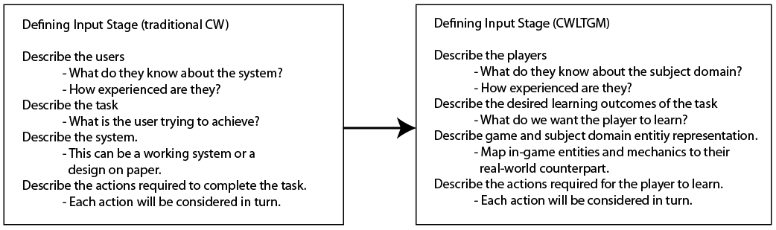
Figure 2: Mapping the Defining Input parts of CW to Learning Through Game Mechanics
As illustrated in Figure 2, the key difference between CW and CWLTGM at this stage is that the focus is not on what the player is trying to achieve, but rather on what the designer wants the player to learn.
The Walkthrough part of the CWLTGM uses the player and system description to ask whether the list of actions that defines the intended experience is likely to result in successful learning.
4.2 Walkthrough stage
As in the previous stage, the first three parts of the Walkthrough stage are mainly contextualised for the GBL setting. These function very similarly to a traditional CW. They serve to ask whether or not the user will carry out the correct actions, but they don’t try to ascertain whether or not this results in learning.
The key contribution and main benefit of CWLTGM lies in Step 4.
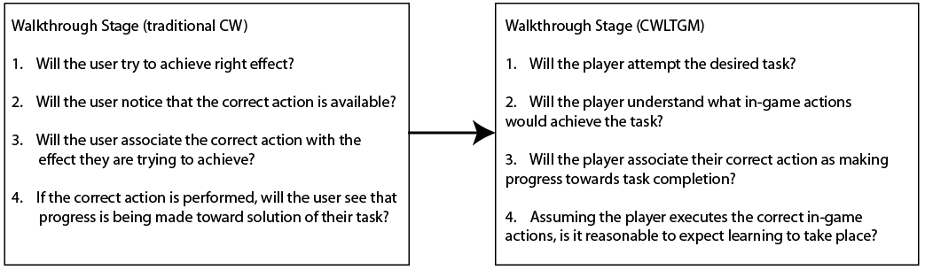
Figure 3: Mapping the Walkthrough stage of CW to CWLTGM
If the evaluator reaches this step with no ‘failures’, one can assume that the player is interacting successfully with the GBL as a game. In order to better estimate the success of learning, one must examine closely the list of actions identified in the Defining Inputs stage and decide whether it is likely that the user will understand the meaning these are intended to convey.
For any GBL game, the designer must have assumed that the player would understand the meaning implied by her actions. But these assumptions may be misplaced. The purpose of the fourth step is to draw attention to these assumptions and allow the designer a chance to spot potential mistakes or areas where it is unlikely that the player will understand the intended meaning of an interaction.
4.2.1 Step 4 of the Walkthrough stage
Step 4 is broken down into a series of sub steps.
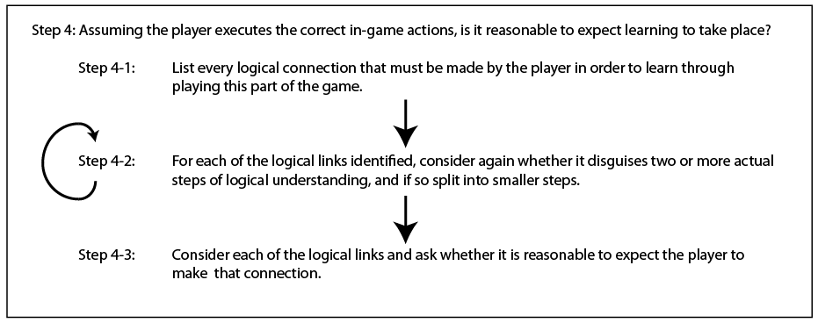
Figure 4: Step 4 of CWLTGM broken down into sub-steps.
Step 4-1: List every logical connection that must be made by the player in order to learn through playing this part of the game.
The purpose of this step is to transform the ‘list of actions’ created during the Defining Input stage into a set of logical inferences required for the player to learn from these actions.
For each action, the evaluator should ask questions like:
- Which game entities must the player recognise as having subject domain meaning?
- Which game entity interactions must the player recognise as having subject domain meaning?
Generally, the evaluator must try not to miss any ‘leaps’ of logic, but rather detail each small logical link that the player must make in order to complete the chain of inferences expected to lead to learning.
Step 4-2: For each of the logical links identified, consider again whether it disguises two or more actual steps of logic, and if so split into smaller steps.
Naturally, the evaluator is prone to the same kinds of mistakes of assumption and expectation as a designer. However, by pausing and re-examining each step of logical inference, we provide an opportunity for an evaluator to spot mistakes.
Step 4-3: Consider each of the logical links and ask whether it is reasonable to expect the player to make that connection.
With close reference to the player description created earlier, the evaluator should ask questions like:
- Will the player understand the visual metaphors?
- Will the player read and understand required text?
- Will the player’s attention be drawn to the correct elements?
- Will the player understand that the meaning of game interactions has a subject domain application?
For each of the logical links, the evaluator should write a few sentences about the likelihood of the player making or missing this connection. Links can be categorised as low risk if it is likely the player will make the connection; moderate risk if the player should make the connection, but there is enough doubt to warrant further attention; high risk if it is unlikely that the player will make the connection.
4.3 Summarising Findings
As with a traditional CW, the evaluator summarises findings in a fashion relevant for the next stage of a project.
If used during the design process, results of CWLTGM applied to a design can motivate actions prior to expensive development. High risk areas should be redesigned as they are fundamentally flawed - the redesign should aim to support the player’s understanding of the broken chain of logic. Moderate risk areas are assumed to be successful, but by identifying uncertainty at this stage, focus groups and preliminary assessments can be used to confirm expectations.
In a final evaluation phase, it may be too late to alter a game, but by examining successful and unsuccessful parts, we gain greater insight into our practice and share results with the community.
5. Applying CWLTGM to the e-Bug Platform Game
We applied the CWLTGM in an evaluation role to see if it could explain confusing results. Two sections of the game were chosen that appear to be very similar in their implementation, pedagogical approach, and complexity and yet differ in their effectiveness of improving knowledge in players.
The CWLTGM resulted in a lengthy report, the key findings of which have been discussed in this section. For brevity many of the details have been summarised. It is worth noting however, that much of the value of CWLTGM lies in attention to detail absent in the summary.
The first section chosen was aimed at teaching “soap can be used to wash bad bugs from hands.” This section was successful in changing knowledge (P=0.02, x²=5.28). In this ‘Soap Section’ of the game, the player can press a button to throw some soap. If the soap hits one a ‘bad bug’ it is washed away with a suitable animation.
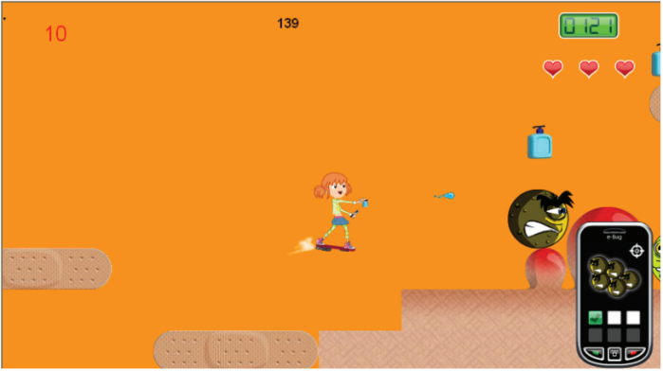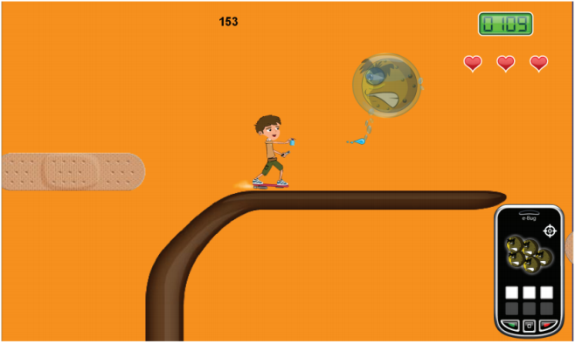
Figure 5: The player throws soap at bad bugs, which are washed away.
The second chosen section was aimed at teaching two LOs: “Our bodies have natural defences that protect us from infection.”; “Most coughs and colds get better without medicine.” This “Natural Defences” section of the game was not successful in achieving knowledge change (P=0.21, x²=1.6 and P=0.74, x²=0.11 respectively).
The difference in performance of these sections was surprising since they both employ very similar game mechanics. In this section, the player can press a button to throw a white blood cell. If they hit a virus, it is killed with a suitable animation. At design time, it appeared as though these two sections were almost identical, with only the “bullet” differing between them.
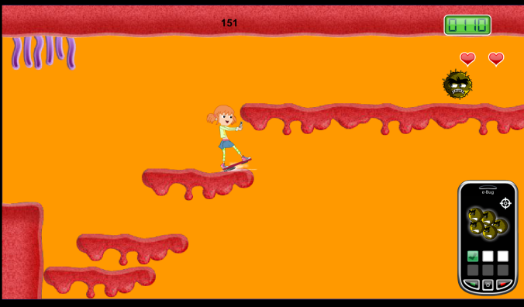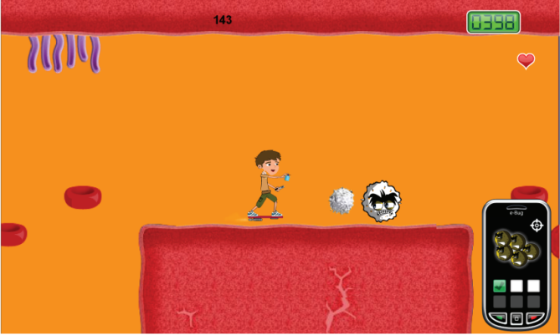
Figure 6: The player throws white blood cells at a virus which is killed.
The player was expected to understand the meaning of their actions, not just in terms of ‘shooting’ an enemy, but also in subject-domain terms of ‘washing away’ or ‘killing’ microbes.
For both sections, the first three steps of the CWLTGM were considered ‘successful’. Players could reasonably be expected to perform the actions (throwing items at bugs) required to finish the level. The analyses diverged in Step 4.
5.1 Walkthrough of learning: Soap Section
For the successful Soap Section, the game actions were converted into the following inferences:
- The player must realise that the environment in which they play represents a human hand.
- The player must understand that she isn’t “firing bullets” but rather throwing soap.
- The player must realise that the game’s placement of bad bugs on skin represents the reality that we have harmful bugs on our skin.
- The player must realise that the bad bugs are being washed away by the soap.
- The player must realise that the bad bugs are bugs, and not aliens or other enemies.
- The player must realise that this doesn’t just happen in the game; it represents reality in that soap is used in real life to remove microbes from the hand.
- The player must understand holistically that washing her hands will remove harmful bugs.
Each of these steps of required logical inference was examined for ‘risk’ of the player not understanding the semantic meaning behind their actions.
When condensing the findings for this paper, it became apparent that most of the logical links above depend on the results of one question. “Would the combination of the introductory text and the art chosen for the game element referred to in the logical step be sufficiently communicative to reasonably expect the player to make the logical inference?”
The majority of the inferences in this section were considered low risk and only three were considered moderate risk.
Link 5 requires that the player read and understand some text that may be misunderstood.
Links 6 and 7 identify a possible “gulf of meaning” where the player may restrict her interpretation of the game’s meaning to its fiction.
5.2 Walkthrough of learning: Natural Defences Section
At the end of Step 4-2, the following logical inferences were identified:
- Player must realise that the environment they are playing in represents "inside a human body".
- Player must realise that the bad bugs are microbes (viruses) and not aliens etc.
- Player must realise that the game's placement of the virus inside the body represents the real-world concept of a human being infected with a virus.
- Player must understand that she isn't just shooting bullets, or throwing soap, but rather is throwing white blood cells.
- Player must realise that the bad bugs when hit by the WBC are being killed.
- Player must realise that "white blood cells" are the body's natural defences.
- Player must realise that this doesn't just happen in the game; it represents reality in the sense that white blood cells kill infections.
- Player must realise that most “coughs and colds” are viruses.
- Player must understand holistically that this means that their body can kill most infections like colds and flu’s by itself.
Only links 1, 2, and 5 were considered low risk. Links 7 and 9 were considered moderate risk due to the potential gulf of meaning mentioned previously. The other links were categorised as high risk.
Whilst the specifics of each failure are important for this particular design, they generally failed for four reasons:
- the player was considered unlikely to recognise the artwork as representing the desired domain concept from sight alone because the concept is new to the player (e.g. white blood cells);
- the introductory text was unlikely to be understood (25 sentences over 5 screens, each shown for 5 seconds);
- the language used in the game is not consistent with the test question asked (e.g. the game referred viruses, yet the quiz refers to “coughs and colds”);
- there were too many new concepts being introduced to reasonably expect the player to understand the semantic mappings.
6. Discussion and further work
The sections of the game analysed were designed by the same team of scientists, teachers and game developers, with the same process and with the same pedagogical underpinnings and were expected to be equally effective. It was a surprise to see such a degree of variance. The results of the walkthrough were genuinely surprising. It seems ridiculous in hindsight to have expected the Natural Defences section to succeed, but we did and could not understand, to our satisfaction, the reason for the difference.
By definition, you cannot design a game to teach without some idea for how it is going to do so, but it is very difficult for people to find and critique their biases, implicit assumptions and logical fallacies. CW is a very simple tool but it offers a way to support one’s critical thinking and help the expert designer to identify these mistakes.
We applied the CWLTGM in an evaluatory role against two sections of one game. Future work should assess its usefulness in understanding the results of other games that also teach through game mechanics. Similarly, whilst it is expected that applying a CW during the design phase should reduce risk, this should be investigated further.
CW is a general approach and the CWLTGM presented here is only really applicable to games that use a constructively aligned, game mechanic based approach to teaching through play. Other extensions should be proposed and evaluated for supporting other types of learning in games.
7. Conclusion
We argue that Cognitive Walkthrough (CW), which is currently widely regarded as an interface usability tool, should be adopted as a cognitive support tool for Games Based Learning (GBL) and other domains that rely on predicting how a user will think. Using CW during the design process can expose hidden flaws in reasoning of the design team.
Using CW in an evaluation of a game can provide plausible reasons for knowledge change results that might help understand why an element of a design was or was not successful.
Because different pedagogical approaches in GBL are based on different expectations of effects, CW is best considered a general approach that should be extended to fit a pedagogy’s underlying theoretical basis.
We presented a proof of concept of this idea with an extension of Cognitive Walkthrough for Learning Through Game Mechanics (CWLTGM). We applied our CWLTGM to the e-Bug game that has been evaluated for knowledge change to understand why two sections that appeared to be very similar, had differing results. The results suggested several plausible and unexpected reasons why one section failed to achieve significant knowledge change, whilst the other succeeded. Future work is necessary to establish the general validity of the technique and its usefulness during design.
References
Antona, M., Mourouzis, A. and Stephanidis, C. (2007). Towards a Walkthrough Method for Universal Access Evaluation. Proceedings of the 4th international conference on Universal access in human computer interaction: coping with diversity, pp. 325–334.
Biggs, J. (1996). Enhancing teaching through constructive alignment. Higher Education, 32, pp 1-18, [online], Available http://www.springerlink.com/index/l2q3820h2436l607.pdf [17 July 2013]
Cook, D. (2006). What are game mechanics?, [online], Available http://www.lostgarden.com/2006/10/what-are-game-mechanics.html [17 June 2013].
Dormann, C. and Biddle, R. (2008). Understanding Game Design for Affective Learning. Fututre Play 2008, pp 41–48.
Farrell, D., Kostkova, P., Weinberg, J., Lazareck, L., Weerasinghe, D., Lecky, D. M., and McNulty, C. a M. (2011). Computer games to teach hygiene: an evaluation of the e-Bug junior game. The Journal of antimicrobial chemotherapy, 66 Suppl 5, v39–44. doi:10.1093/jac/dkr122
Foster, A. N., and Mishra, P. (2009). Games, Claims, Genres, and Learning. Handbook of Research on effective electronic gaming in education, pp 33–50, [online], http://punya.educ.msu.edu/publications/foster-mishra-08.pdf [17 July 2013].
Freitas, S. D. (2006). Learning in Immersive worlds A review of game-based learning. Bristol, UK: Joint Information Systems Committee (JISC) Report. [online], Available http://www.jisc.ac.uk/media/documents/programmes/elearninginnovation/gamingreport_v3.pdf [17 June 2013]
Kiili, K. (2007) “Foundation for Problem-Based Gaming”, British Journal of Educational Technology – Special issue on Game-Based Learning, Vol 38, No. 3, pp 394-404.
Kiili, K. (2008). Reflection walkthrough method: designing knowledge construction in learning games, Proceedings of 2nd European Conference on Games Based Learning, Catalunya, Spain, pp. 237–241.
Kirriemuir, J. (Ceangal), and McFarlane, A. (University of B. (2004), Literature Review in Games and Learning, Futurelab Report, Bristol.
Koster, R. (2005). A Theory of Fun for Games Design. Paraglyph Press.
Mitchell, A., and Savill-Smith, C. (2004). The use of computer and video games for learning: A review of the literature. Development. Learning and Skills Development Agency, [online], Available http://dera.ioe.ac.uk/5270/1/041529.pdf [17 June 2013]
Novick, D. Using the cognitive walkthrough for operating procedures. Interactions, 6(3):31-37, 1999
Plass, J., Homer, B., Kinzer, C., Frye, J., and Perlin, K. (2011). Learning Mechanics and Assessment Mechanics for Games for Learning. Games for Learning Institute White Paper, [online], Available http://g4li.org/wp-content/uploads/2011/11/G4LI-White-Paper-01-2011-Learning-Assessment-Mechanics.pdf [17 June 2013]
Shaffer, D. W. (2006). How computer games help children learn, Media, Vol. 1, pp. 256, Palgrave Macmillan. doi:10.1057/9780230601994
Squire, K. (2004). Replaying history: Learning world history through playing Civilization III. Indiana University, Indianapolis, [online], Available http://website.education.wisc.edu/kdsquire/dissertation.html [17 June 2013]
Wharton, C., Rieman, J., Lewis, C. and Polson, P. (1994), The Cognitive Walkthrough: A practitioner’s guide, In J. Nielsen & R. L. Mack (Eds.), Usability inspections methods, New York: Wiley, pp 105-140.
Wideman, H. H., Owston, R. D., Brown, C., Kushniruk, A., Ho, F., and Pitts, K. C. (2007). Unpacking the potential of educational gaming: A new tool for gaming research. Simulation & Gaming, 38(1), pp 10–30. doi:10.1177/1046878106297650
Norman, D. A., and Draper, S. W. (Eds.) (1986). User centered system design: New perspectives on human-computer interaction. Hillsdale, NJ: Lawrence Erlbaum Associates

